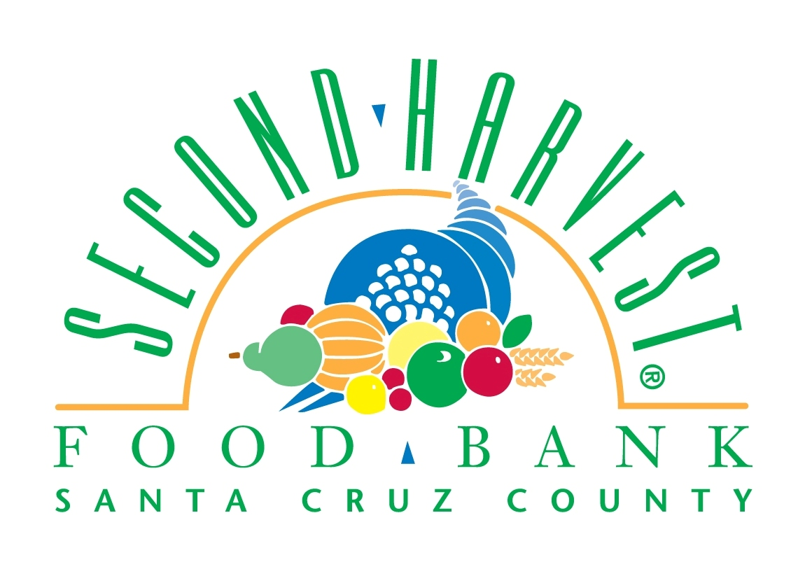
Second Harvest Food Bank Santa Cruz County
Chief Operations Officer

Second Harvest Food Bank provides over 8 million pounds of food assistance annually, to over 55,000 people per month, through its network of 200 member agencies and programs. By increasing access to healthy foods, Second Harvest is making a profound impact towards growing healthier kids while reducing diet-related disease.

JOB ANNOUNCEMENT
Are you a leader looking for an opportunity where your talent can make a meaningful difference for people every day? Join Second Harvest’s outstanding executive team and leverage your warehousing, logistics, and outreach expertise to make an impact on our community. The ideal candidate will be passionate about our mission, driven, and ready to play a strategic leadership role.

The Chief Operations Officer (COO) has the opportunity to build on Second Harvest’s services and programs while increasing efficiency and effectiveness in our mission. If these statements describe you, this may be the opportunity you have been looking for:
- You enjoy being part of and building high-performing teams.
- You thrive on creating and implementing new processes and initiatives.
- You relish rolling up your sleeves and “doing” just as much as delegating.
- You embrace working closely with a fantastic team of volunteers, staff and board members.

JOB SUMMARY
REPORTS TO: CEO
SUPERVISES: Director of Agency Network Services, Director of Community Outreach, Senior Manager of Facilities and Safety, Warehouse Manager, Hotline Manager

This position has three key areas of focus in order to make sure that the community’s food and nutrition needs are met:
- Ensures the healthy running of our Warehouse alongside our Warehouse Manager, including; inventory management, food safety, audit compliance, and efficient receiving/shipping methods.
- Manages the outreach and advocacy work of our CalFresh (formerly known as food stamps) and Hotline programs. These two programs go out into the community to inform, educate and recruit community members to take advantage of the food benefits (and other resources) they qualify for.
- Oversees the strategic planning of our Agency Network; mapping gaps in access to food distribution points, creating streamlined push models for our agency food pickups and deliveries, and creating strategic food donor and agency partnerships.

RESPONSIBILITIES
Leadership
- Forges and maintain positive relationships with internal stakeholders (staff, volunteers, etc)
- Ensures strong positive Relationships with external stakeholders. (food donors, vendors and contractors)
- Directs, manages, supervises, evaluates, trains and motivates staff.
- Provides direct supervision, periodic performance evaluations, job description updates, and recommends salary adjustments for members of the operations team.
- Ensures that operations department staff receives appropriate training in key job elements, cross training, volunteer supervision and food bank policies and procedures.
- Monitors operations department spending against department budgets.
- Guarantees the successful completion of department goals and projects, as required by outside grants and contracts.
- Communicates effectively and respectfully with people from different racial, ethnic and cultural groups and from different backgrounds and lifestyles; demonstrates knowledge of and sensitivity to their needs.

Warehousing, Logistics, Compliance and Auditing
- Works with the Warehouse Manager to ensure the highest operating efficiency of warehouse operations including receiving, distribution, food sourcing, transportation, inventory management, and food safety.
- Insures compliance to Department of Health, FDA, USDA, OSHA, DOT, and all other regulatory agencies and laws governing business operations. Delivers satisfactory scores on 3rd party food safety audits currently performed by AIB (American Institute of Baking). Responsible for compliance with Feeding America’s applicable guidelines resulting in satisfactory monitoring visits.
- Insures compliance with USDA, CDSS (California Department of Social Services) requirements for Agency Partner Agreements, Storage, Distribution, and Reporting of TEFAP (Emergency Food Assistance Program) commodities. Provides agency training in accordance with government program requirements.
- Creates a strategic vision for making our warehouse logistics more smooth, efficient, and automated.
- Oversees a strong strategic partnership between warehouse, programs and agencies.

Food Procurement & Distribution
- Works with the Director of Agency Network Services to promote donation of varied, nutritious foods for distribution to clients.
- Oversees quality agency relations services, including agency compliance and record keeping and retention.
- Provides strategic vision for the future of ANS; including streamlining opportunities, process improvements, and upgrades to distribution and procurement methods.

Business Process Development
- Researches, recommends and implements improvements to business processes and procedures
- Develops systems and procedures that ensure smooth functioning of the operations department; documents and updates procedures and trains staff on policies and procedures.
- Evaluates each area of operations, performs departmental audits to determine cost benefit and systematically reports these results to the CEO Recommends changes as necessary to improve systems or to enhance customer service.

Performs other duties as assigned.
QUALIFICATIONS:
Education, Training & Experience
A BA/BS degree and at least five years of progressively responsible experience managing warehouse distribution centers that includes three years of supervisory, administrative, and organizational experience, or the equivalent combination of education and experience.

Knowledge, Skills & Abilities
- Effective problem-solving/analytical skills
- Able to think strategically and translate strategies into actionable plans
- Knowledge of budgeting and administration.
- Knowledge of warehouse operations, food safety, and inventory control.
- Ability to supervise, train, evaluate, motivate, and retain staff.
- Ability to develop and maintain effective working relationships with staff, members of other agencies and community organizations, volunteers, donors, and funders.
- Ability to develop business processes.
- Ability to prepare clear and concise written reports and verbal presentations.
- Ability to work as a part of the executive team to promote the vision and mission of Second Harvest. This includes friendly communication, teamwork, employee satisfaction, and employee retention.
- Ability to resolve conflicts and facilitate meetings.
- Ability to interact positively with a diverse community of staff and volunteers
- Ability to use Microsoft Office software, databases, MS Ceres Navision, and/or other inventory/financial software programs.
- Working knowledge of Food Safety regulations related to the Bioterrorism Act & Food Safety Modernization Act.
- Working knowledge of DOT and CARB compliance and DMV licensing requirements.
- Solid project execution skills.

Physical Requirements
- Able to lift up to 50 pounds.
- Able to see and read documents.
- Able to walk up and down stairs.
- Able to hear normal conversations on the phone and in person.
- Able to work in a cold environment.
- Able to stand and walk for up to four hours.
- Bi-manual dexterity and able to use a computer keyboard.

Salary Range: $75,000-85,000, depending on experience
To Apply: Please send cover letter and resume by December 31, 2017 to hiring@thefoodbank.org

SECOND HARVEST FOOD BANK SANTA CRUZ COUNTY IS AN EQUAL OPPORTUNITY EMPLOYER.
The Second Harvest Food Bank does not discriminate against any employee or applicant for employment because of ancestry, age (40 and above), color, disability, genetic information, gender identity, gender expression, marital status, medical condition (genetic characteristics, cancer or a record or history of cancer), military or veteran status, national origin, pregnancy, race, religion, sex/gender, sexual orientation, or any other non-merit factor unrelated to job duties.

